
Project Report
On

Building Real Time Sales Dashboard - Google Looker

Made By-
Rizpah Patole
(2301010219)
&
Harman Jeet Singh
(2301010252)
B.Tech CSE

Submitted To:
Ms. Mansi Kajal
(Software Engg.)

Introduction
The main goal of this project is to identify which companies are hiring the most for specific roles especially Data Engineers and Data Scientists and understand how factors like job location, qualifications, posting dates, and candidate preferences affect hiring patterns.
To achieve this, I collected and cleaned a dataset of job descriptions, converted the raw information into a structured format, and applied different filters such as country constraints, gender preference, role-based filtering, and date ranges. After processing the data, I used visualization techniques to highlight the top 10 companies with the highest number of relevant job openings.
This project helps in understanding hiring trends, skill demand, and real-world recruitment patterns, which are extremely valuable for students and professionals entering the tech and data field.”

Organization Overview
I project focuses on delivering analytics-based insights for business growth. The company supports various teams like marketing, operations, and product management by providing accurate and timely data insights.

Objective of the Internship
The main objective of my project was to gain practical experience in data visualization and business reporting using Google Looker Studio. I was responsible for transforming raw transactional data into clear, actionable dashboards and charts that would help different teams — including Marketing, Sales, Operations, and Customer Service — make informed decisions. By working on real datasets and queries, I learned how to understand business requirements and translate them into meaningful visual insights.

Tools & Technologies Used
- SQL for data querying
- Python (Pandas, Matplotlib, Seaborn) for analysis
- Jupyter Notebook as the development environment
- MS Excel for initial checks
- Looker Studio for dashboard visualization

Queries Performed:

Top Products by Sales for Year-End Planning
One of my first tasks was to identify the top 5 products in the Mobiles & Tablets category based on total sales quantity for the year 2022. I filtered the data to include only valid orders and grouped it by product name and category. I created calculated fields to extract the year from the order date and applied filters to display only relevant data. Using this, I built a horizontal bar chart ranking the top-performing SKUs by total units sold. This helped the Marketing Team plan their Year-End Festival by focusing promotions on the most popular products.

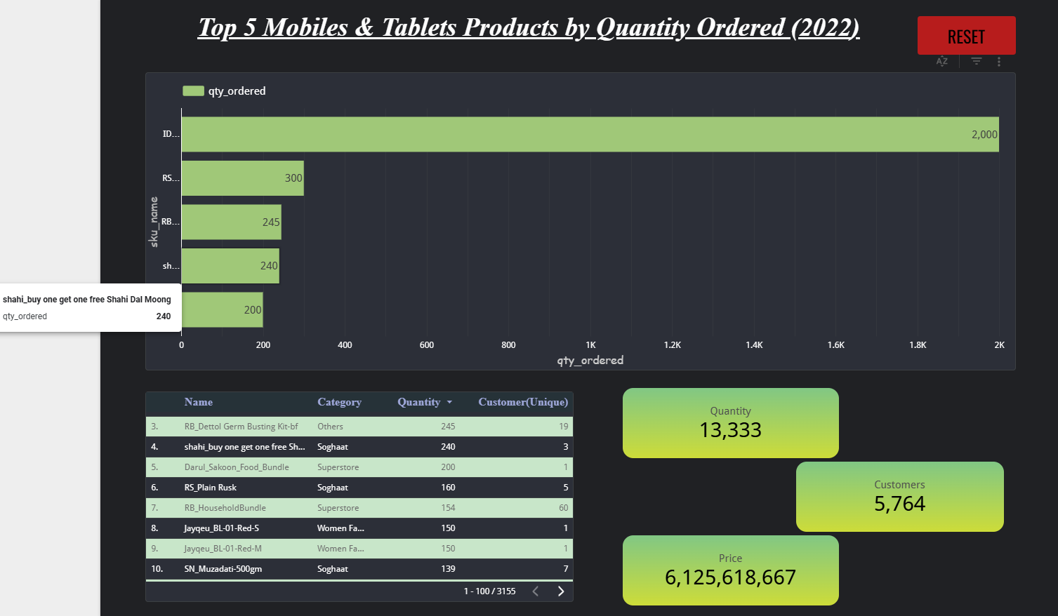

Products with the Largest Decrease in Sales
Next, I analyzed which products showed the most significant drop in sales when comparing 2022 with 2021. I blended two datasets for both years, grouped by product, and calculated the difference in total quantities sold. I then created a bar chart showing the top 10 products with the largest negative sales difference. Supporting scorecards displayed total units lost, total sales for each year, and the percentage of products that declined. This analysis enabled the Sales Team to identify underperforming products and explore possible causes.

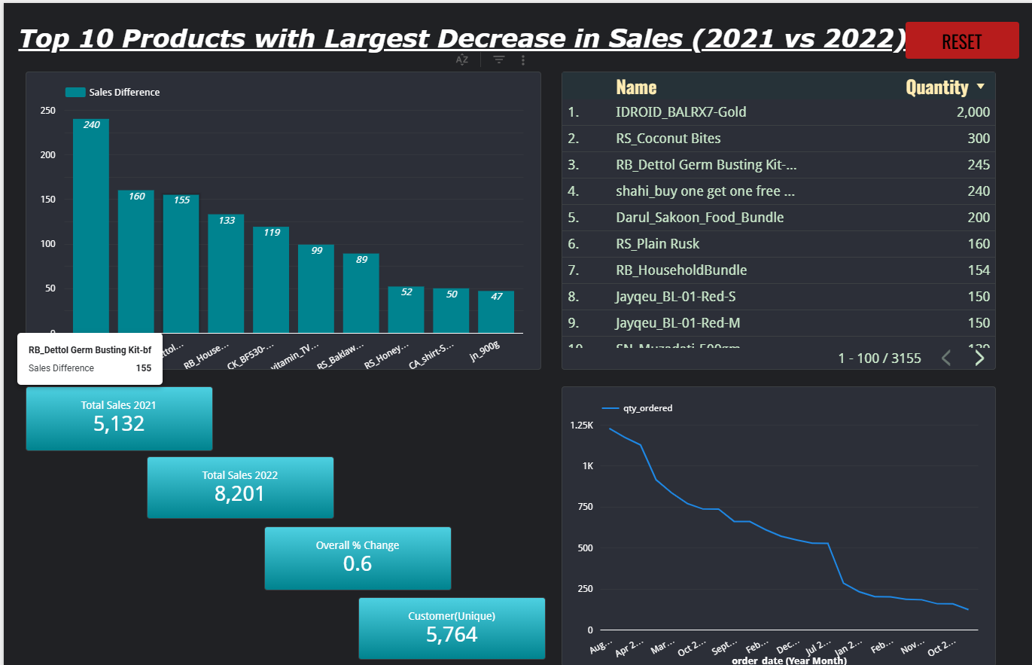

Net Profit Analysis by Product Category
For the Operations Team, I developed a report showing the net profit performance of different product categories. I created a calculated field to determine net profit by subtracting the cost of goods sold (COGS) from revenue after discounts. I visualized this using a bar chart, sorted by highest to lowest net profit, and added a slicer for year filtering. This helped the team quickly identify which categories contributed most to profit and supported strategic inventory decisions.
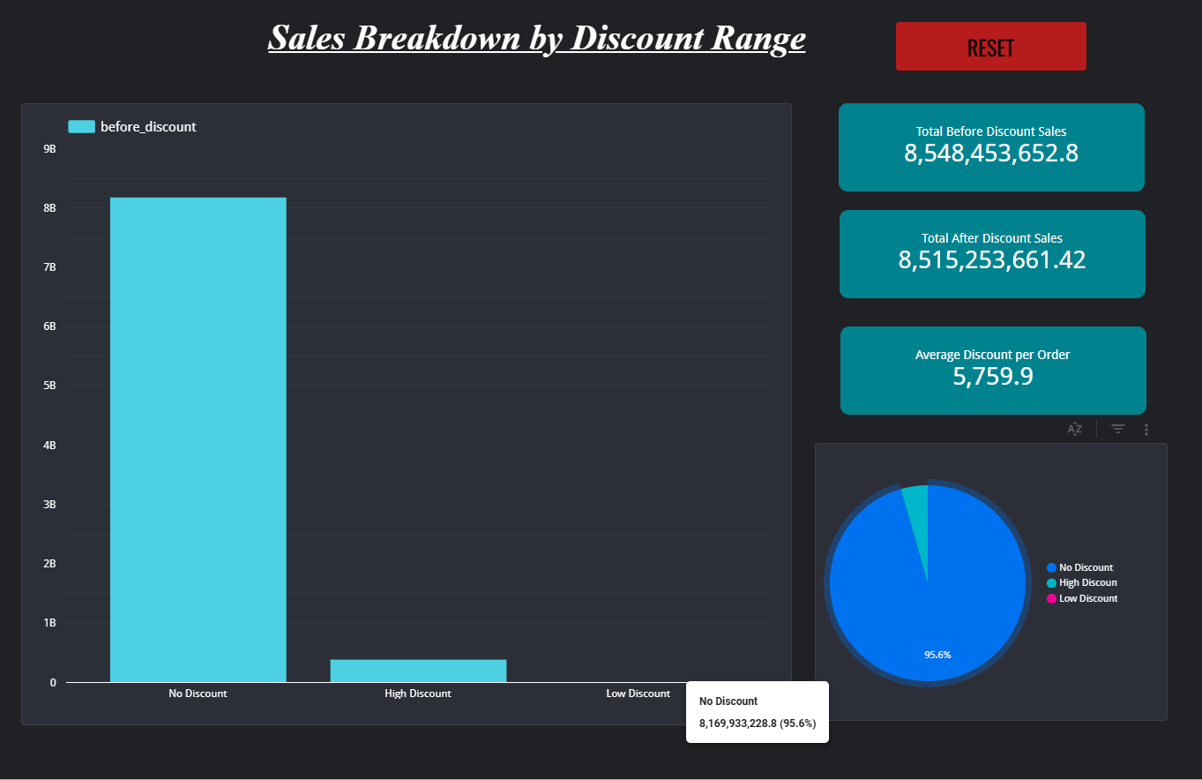

Customer Purchase Behavior
Finally, I worked on understanding customer purchasing behavior, specifically identifying the number of unique customers and those who made repeat purchases in 2022. I created calculated fields to count distinct customers and segment them into first-time or repeat buyers. I added scorecards to display the counts and their ratio and visualized trends using line and pie charts. This analysis helped the Customer Service Team understand customer loyalty and plan engagement strategies to retain repeat buyers.
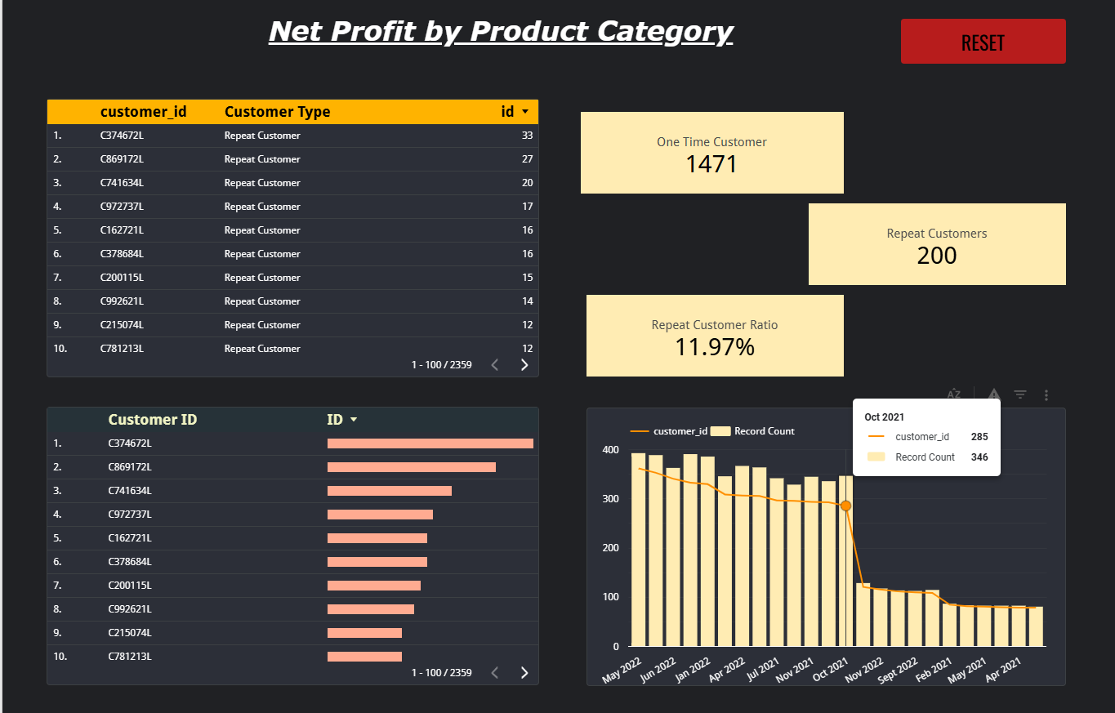

Key Learnings
- Data Blending: I learned how to join multiple datasets and match them using common keys (like sku_name) to compare time periods.
- Custom Calculations: I gained hands-on experience creating CASE statements, IF conditions, and simple mathematical formulas within Looker Studio.
- Visual Design: I understood how to select appropriate charts (bar, pie, line) to represent different insights clearly.
- Business Context: I improved my ability to interpret raw data in a way that addresses specific business questions, such as identifying underperforming products or analyzing repeat customer behavior.
- Error Troubleshooting: I learned how to debug common Looker Studio issues like aggregation errors and unsupported expressions.

Challenges Faced
- Re-aggregation Errors: One key challenge was understanding how Looker Studio handles aggregated vs. non-aggregated fields. I learned the difference between data source-level and chart-level calculations to resolve these errors.
- Data Preparation: Some required fields like discount_amount were not directly available, so I had to create them using other columns (e.g., before_discount - after_discount).
- Blending Limitations: Managing blended data sources required careful attention to join keys and matching fields to ensure the charts displayed the right metrics.
- Visual Clarity: Deciding which chart types would best communicate the data without clutter took some trial and error.

Future Aspects of the Project
- Automated Real-Time Hiring Insights
The project can be extended to automatically update dashboards as new job postings appear online.
- Predictive Hiring Trends
Machine learning models can be added to predict future demand for Data Engineer or Data Scientist roles based on historical patterns.
- Advanced Geographical & Demographic Analysis
Additional filters like salary range, seniority level, or company size can help provide deeper insights.
- Integration with Job APIs
Connecting with platforms like LinkedIn, Indeed, or Naukri APIs can turn the project into a real-time recruitment analytics tool.
- Candidate Recommendation System
The system can be expanded to suggest the best companies to target based on skill sets and preferences.
- Interactive Dashboards for Companies
Companies can use enhanced dashboards to analyze competitor hiring strategies and optimize their own recruitment pipeline.

Conclusion
Overall, this project gave me hands-on experience in building dashboards and using data to answer real-world business questions. I learned how to use Looker Studio’s blending, calculated fields, visual elements, and filters effectively to create clear and informative reports. This experience strengthened my practical skills in data visualization and reporting, which will be valuable for my future projects and career.

